**Lab 2:** DDL Commands

________________________________________________________________________

**Objective:** The student will start making use of DDL commands.

**Course Outcome CO1:** Students will be able to use DDL – create/alter table statement – to create relations along with the constraints specified.

**Blooms Taxonomy Level**: BT2, BT3

1. Employee (eno char(3), ename varchar(20), eadd varchar(30), ephone char(8), esal int, grade char(1), edoj date, dno char(3), emgrno char(3))

* PRIMARY KEY – eno
* FOREIGN KEY – dno refers to Department relation
* FOREIGN KEY – emgrno refers to eno of Employee relation
* salary can hold values between 1000 and 60000
* grade can be A – if salary less than 20000, B – if salary is between 20000 and 40000, C – if salary is greater than 40000
* doj should be more than 01-jan-1990
* ephone can have unique values only

show databases;

create database Lab2;

Use Lab2;

create table Department(dno char(3), dname varchar(20) not null, dloc varchar(20) default 'Delhi', dhead char(3), primary key(dno));

desc Department;

create table Employee(eno char(3) primary key, ename varchar(20), eadd varchar(30), ephone char(8) unique, esal int check (esal between 1000 and 60000), grade char(1) default (case when esal<20000 then 'A' when esal>20000 and esal<40000 then 'B' when esal>40000 then 'C' else null end), edoj date check (edoj > '1990-01-01'), dno char(3), emgmo char(3), foreign key(dno) references department(dno));

desc Employee;

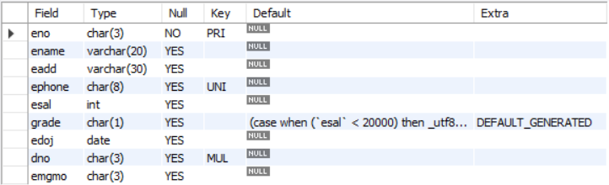

1. Proj_alloc (eno char(3), pno char(3), hrs int)

* PRIMARY KEY – eno, pno
* FOREIGN KEY – eno refers to Employee relation
* FOREIGN KEY – pno refers to Project relation
* hrs can have values more than 2

create table Proj_alloc(eno char(3), pno char(3) primary key, hrs int, foreign key(eno) references Employee(eno));

desc Proj_alloc;

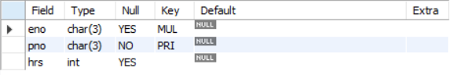

1. Dependent (eno char(3), dpname varchar(20), dpdob datetime, dprelation varchar(20))

* PRIMARY KEY – eno, dpname
* FOREIGN KEY – eno refers to Employee relation
* Dprelation can have only one of the values {son,daughter,father,mother}

create table Dependent(eno char(3), dpname varchar(20) primary key, dpdob datetime, dprelation varchar(20) check (dprelation in ('son','daughter','father','mother')), foreign key(eno) references Employee(eno));

desc Dependent;

